# 

## 

## Information Management Group 20 Report

## CSU22041

Domain: FastFood Delivery Service

Members: Faith Olopade (21364066),Emeka David Odoemelam (20334547), Kate O Neill (21365768), Luke O Rourke (21365366), Orson O Sullivan (21360888), Kostiantyn Ohorodnyk (20336895)

# 

# 

# 

# 

# 

# 

# 

# 

# 

# 

# 

# 

# 

# 

# 

# 

Information Management Group 20 Report 1

CSU22041 1

**Background Research** **2**

**Support Tools** **2**

**Distribution of Tasks** **3**

**Ethics Canvas** **6**

**UML Use Cases** **7**

**UML Class Diagram** **10**

**UML Activity Diagram** **11**

**Strengths and Weaknesses** **11**

**References** **12**

# 

# 

# Background Research

In our initial group meeting we agreed to first research our domain ‘FastFood Delivery Service’. We decided to carry out individual research, carry out brainstorming sessions and then select what pieces of information would be most useful to us. We decided on a Fast Food Delivery App as there were more classes, cases and actors to work with. In addition this was a system we had all used previously at one point or another so we had a personal interest in this particular system.

Following our decision to focus on the app we researched various Fast Food Delivery Services including Deliveroo, Just Eat, Uber Eats and DoorDash. We researched their different ways of creating an online account, ordering food and making payment. We also searched for the various categories of food available depending on dietary requirements. We also explored other parts of the app in general. Each of us added our thoughts and ideas into a shared document so we could combine this into data we could use for our various UML diagrams.

# Support Tools

Group Communication: In our initial meeting we decided what form of communication would benefit each group member and what platform would best facilitate communication. Some ideas mentioned were emails, Discord and Whatsapp. We later decided on Discord and this is a platform most of our group members use on a regular basis.

File Storage: We made use of Google Drive to store all of our research findings, ideas, video clips for presentation and schedule for when certain parts of our project needed to be completed by. Our reason for using this specific platform was that it is great for collaborating and makes sharing files effortless.It was also a platform most of our group knew how to use and were familiar with.

Video Presentation: We used Canva for our presentation as it has many nice templates for presentations along with engaging colours and images.

Modeling Software.: We made use of ‘draw.io’ as this was recommended to us by a Teaching Assistant during a tutorial session. We initially researched various softwares and landed on ‘Creately’ but after putting both ‘draw.io’ and ‘Creately’ to use we found ‘draw.io’ was the one to go with for the reasons below.

* Official tutorials were available and very easy to follow on the ‘draw.io’ website; these assisted us in getting used to the platform and drawing our various diagrams.
* Full access to the website was free unlike ‘Creatly’ where certain features were paid.
* It was also very easy to save diagrams and copy/paste them into documents.

Based on these benefits we used ‘draw.io’ for our project.

# Distribution of Tasks

From our initial meeting we had a clear understanding of how tasks were going to be divided and we ensured that the division would be fair. To ensure this we scheduled weekly meetings on Discord to check in on everyone’s progress and ensure we were on schedule to meet our weekly goals. We would also discuss our goals for the next week in every meeting we had along with discussing any difficulty people were having with their assigned task.

Below is the distribution of work among ourselves across the weeks.

Week 1 (19/9): We organised our first meeting where we got to know each other, selected a preferable means of communication and decided what aspect of our system to focus our research on. In this meeting we also discussed what diagram we would like to present and chose the ethics canvas as it provided us a good base for the remainder of our diagram.

| Member | Tasks |
| --- | --- |
| Faith Olopade (21364066) | Background Research, Section 5 & 6 of Ethics Canvas, Set up Google Drive, Research drawing tools, Set up Discord |
| Kostiantyn Ohorodnyk (20336895) | Background Research, Section 8 of Ethics Canvas |
| Orson O Sullivan (21360888) | Background Research, Section 4 & 7 of Ethics Canvas |
| Emeka David Odoemelam (20334547) | Background Research, Section 1 & 3 of Ethics Canvas, Research drawing tools |
| Kate O Neill (21365768) | Background Research, Section 9 of Ethics Canvas |
| Luke O Rourke (21365366) | Background Research, Section 2 of Ethics Canvas |

Week 2(26/9): In our second meeting we began to assign the remainder of the tasks required for our project. We asked among ourselves who was most comfortable and confident working on a certain Information Model and split the tasks according to the responses.

| Member | Tasks |
| --- | --- |
| Faith Olopade (21364066) | Start UML Use Cases (1 - 4) |
| Kostiantyn Ohorodnyk (20336895) | Start UML Class Diagram |
| Orson O Sullivan (21360888) | Start UML Activity Diagram #1 |
| Emeka David Odoemelam (20334547) | Start UML Activity Diagram #2 |
| Kate O Neill (21365768) | Start UML Class Diagram |
| Luke O Rourke (21365366) | Start UML Use Cases (5 - 8) |

Week 3(3/10): We met up to discuss our progress so far and finalise our Ethics Canvas so we could begin recording for our presentation. We selected 3 speakers. We also discussed any difficulties people were running into with their respective Information Model and worked as a group to overcome these difficulties. We also started considering what should be included in the presentation of our interim design and the strengths and weaknesses of the design.

| Member | Tasks |
| --- | --- |
| Faith Olopade (21364066) | Finalise Section 5 & 6 of Ethics Canvas, Writing up Report |
| Kostiantyn Ohorodnyk (20336895) | Finalise Section 8 of Ethics Canvas |
| Orson O Sullivan (21360888) | Finalise Section 4 & 7 of Ethics Canvas |
| Emeka David Odoemelam (20334547) | Finalise Section 1 & 3 of Ethics Canvas |
| Kate O Neill (21365768) | Finalise Section 9 of Ethics Canvas |
| Luke O Rourke (21365366) | Finalise Section 2 of Ethics Canvas |

Week 4(10/10): The deadline for our interim design was due this week. We discussed who would present what part of our Ethics Canvas and began writing scripts and recording our sections. While speakers were preparing their scripts other group member were finalising our other Information Models,

| Member | Tasks |
| --- | --- |
| Faith Olopade (21364066) | Writing Script, Recorded Section 5, 6 & 7, Recorded Further Steps for Design and Strengths and Weaknesses of design, Collated Recordings and Created Video Presentation |
| Kostiantyn Ohorodnyk (20336895) | Finalise UML Class Diagram (Not Completed) |
| Orson O Sullivan (21360888) | Writing Script, Recorded Section 4, 7 & 9, Recorded Reason for Focus on This Diagram and Interesting Aspects of Diagram |
| Emeka David Odoemelam (20334547) | Writing Script, Recorded Section 1, 2 & 3, Recorded Overview Describing System, How Diagram was Created and Purpose of Diagram. |
| Kate O Neill (21365766) | Finalise UML Class Diagram (Not Completed) |
| Luke O Rourke (21365366) | Continue UML Use Cases |

Week 5(17/10): Our report is due this week. We assigned someone to write the report while the rest of our group finalised our Information Models.

| Member | Tasks |
| --- | --- |
| Faith Olopade (21364066) | Writing Report, Finalizing UML Use Cases, Putting all Use Cases into One Diagram, Proofreading, Write Design Choices |
| Kostiantyn Ohorodnyk (20336895) | Finalise UML Class Diagram (Not Completed) |
| Orson O Sullivan (21360888) | Finalise UML Activity Diagram |
| Emeka David Odoemelam (20334547) | Finalise UML Activity Diagram, Write Activity Diagram description |
| Kate O Neill (21365768) | Finalise UML Class Diagram (Not Completed), Collating All Classes Into One Diagram |
| Luke O Rourke (21365366) | Proofreading Diagrams and Report |

# Ethics Canvas

Our Ethics Canvas contains information that would allow us identify, evaluate and resolve ethical impacts our system may have if it were ever implemented. This allows us to use our Ethics Canvas as a tool for capture and reflection of ethical implications and allow us to take into account potential stakeholders that may be affected by certain parts of our system.

In our Ethics Canvas we have included information regarding how our design may cause changes in individual behavior and how it may affect relationships between individuals. We have highlighted the macro impacts that need to be considered and included how we can address these ethical impacts by pivoting our design in another direction and proposing broder changes.

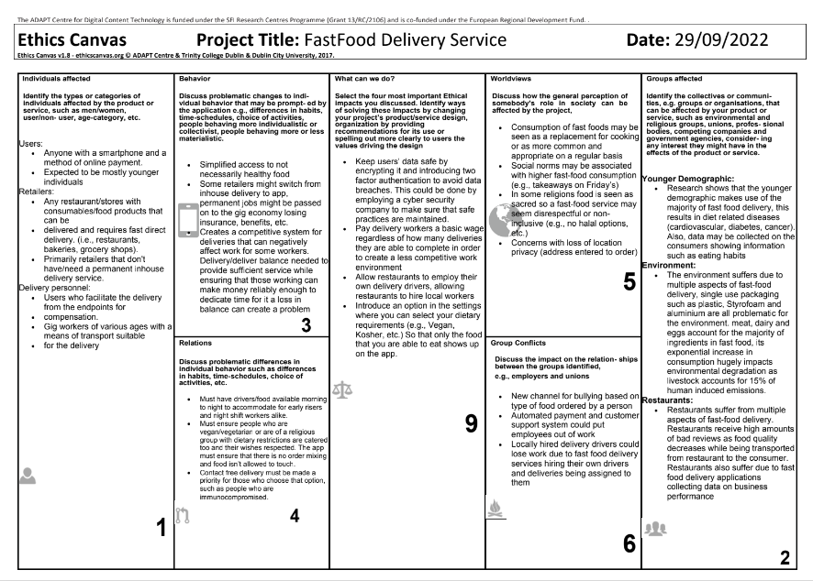

# 

# 

# 

# 

# 

# 

# 

# 

# 

# 

# 

# 

# 

# 

# 

# 

# 

# 

# 

# 

# UML Use Cases

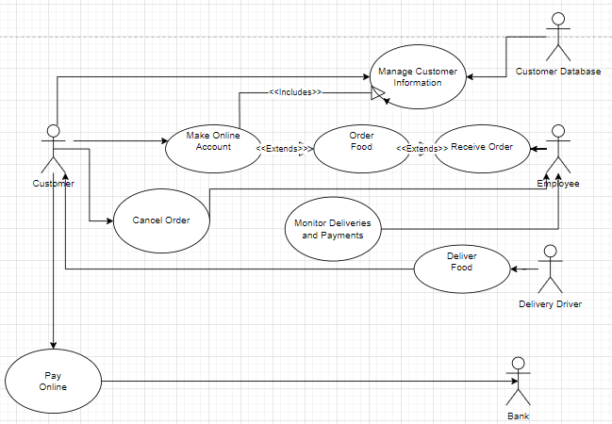

| Name: Make Online Account  Participating Actor: Customer  Entry Conditions :   * Customer goes to website page * Customer has valid details to enter   Exit Condition:   * Customer online account created   Normal Scenario:   1. Customer enters personal details 2. Customer selects items they wish to order 3. Customer chooses payment options 4. Customer enters payment details 5. Online account is created   Error Scenario :   * Customer enters incorrect details * Card verification could not be completed * Online account cannot be created | Name: Order Food  Participating actors: Customer, Employee  Entry condition:   * Customer has online account * Customer wants to order food   Exit Condition:   * Order is prepared   Normal Scenario:   1. Customer places an order 2. Customer selects delivery time 3. Employee receives order 4. Employee prepares order   Error Scenario :   * Order is incorrect * Employee doesn’t prepare order |
| --- | --- |
| Name: Deliver Food  Participating Actors: Delivery Driver, Customer  Entry Condition:   * Customer has food order * Driver has food   Exit Condition:   * Customer has received their order   Normal Scenario:   1. Delivery driver delivers customers food 2. Customer eats food 3. Customers leaves positive review   Error Scenario:   * Driver does not deliver food * Incorrect order delivered * Correct order delivered | Name: Pay Online  Participating Actors: Customer, Bank  Entry Condition:   * Customer selected online payment option * Customer has received total amount due * Customer has sufficient money to pay total amount due   Exit Condition:   * Total amount due is paid   Normal Scenario:   1. Customer logs into online account 2. Customer makes payment 3. Bank takes money from Customer account   Error Scenario:   * Insufficient funds to pay * Customer puts more money in bank |

| Name: Receive Order  Participating Actors: Chef, Employee  Entry Condition:   * Order Received * Food availability   Exit Condition:   * Payment Received   Normal Scenario:   1. Chef Checks order 2. Chef Prepares food 3. Chef Changes order status 4. Employee Gives food to driver 5. Employee Collects payment and create receipt   Error Scenario:   * Incorrect order prepared * Order doesn't get prepared | Name: Monitor Deliveries and Payment  Participating Actor: Employee  Entry Condition:   * Orders are being placed   Exit Condition:   * Food is available * Payment recorded   Normal Scenario:   1. Monitor orders 2. Approve of customer order 3. Check if food is in stock 4. Retrieve customer delivery info 5. Receive and record payment   Error Scenario:  - Food unavailable  - Insufficient funds |
| --- | --- |
|  |  |
| Name: Manage Customer Information  Participating Actors: Customer, Customer Database  Entry Condition :   * Customer uses application   Exit Condition   * Customer Information updated   Normal Scenario:   1. Customer enters required information 2. Customer Database validates and saves consumer data 3. Customer Database presents list of available food 4. Customer Database updates customer delivery status   Error Scenario:   * Incorrect information entered | Name: Cancel Order  Participating Actors: Customer, Employee  Entry Condition:   * Customer wants to cancel order   Exit Condition:   * Cancellation confirmed   Normal Scenario:   1. Customer selects “Cancel Order” 2. Customer enters reason for order cancellation 3. Employee confirms cancellation and refund 4. Customer receives refund and order cancellation   Error scenario:   * Order not cancelled |

# UML Class Diagram

Unfortunately Kate O Neill (21365768) and Kostiantyn Ohorodnyk (20336895) were unable to complete the class diagram. Below is an interim class diagram created.

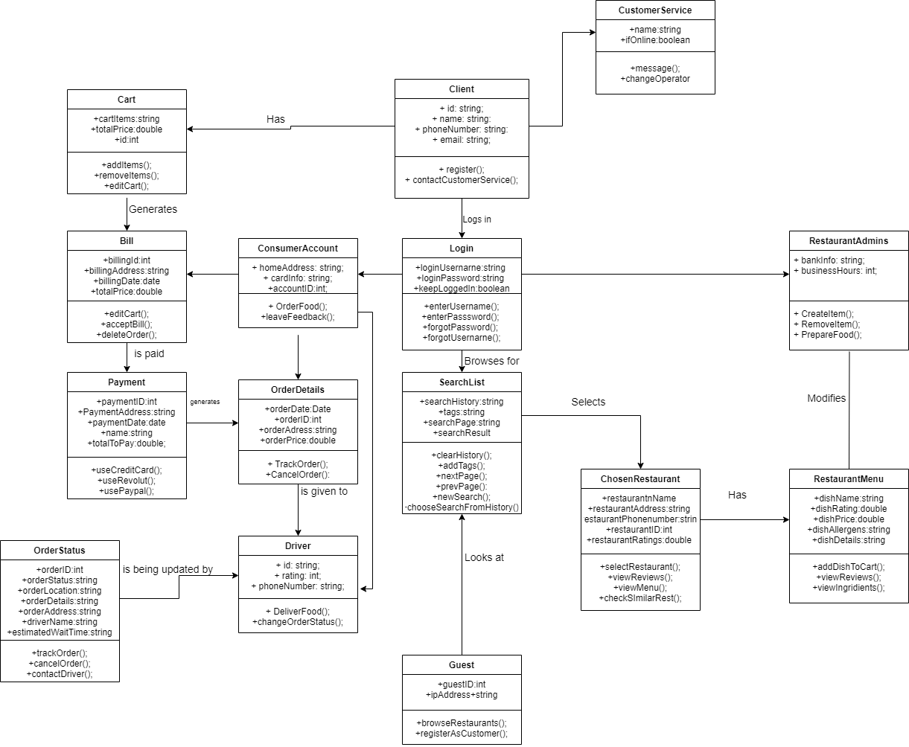

Design Choices

We brainstormed several different ideas of how our UML Class diagram should look like. We eventually settled on focusing on the customer and how they would interact with our FastFood Delivery Service system.

We choose these classes as they match the functionality expressed in the Use Case diagram.

We decided to keep all attributes public until the next iteration of the diagram.

We chose to model these classes as they are the most complex and of most interest to end users.

We laid out the diagram in such a way to support communication with different stakeholders

# 

# UML Activity Diagrams

# 

Activity Diagram 1 Description

Title: Food Delivery

Swimlanes: Driver, Customer, Service, Restaurant

Summary: This activity diagram displays the workflow of the process of food being delivered to a customer from a selected FastFood Delivery Service.

The process has 4 actors, the customer, the restaurant, a delivery driver and the service itself. Once the order is posted the service finds a free driver close to the pickup and assigns an order to them, with a set fee, if the driver accepts. Following this the driver picks up the order and delivers it to the customer all while the service tracks their progress and updates the customer. Once the delivery is complete the driver confirms the delivery and so does the customer (potentially through lack of complaint). Once the service has confirmation of the delivery it pays the driver the fee.

It contains the actions needed to coordinate the parties taking place in the delivery to create a seamless experience for the customer. It is based on documentation found online and personal experience and the use case of the same name.

Creation Date: 19/10/2022

Precondition: This chain of events takes place following the confirmation of an order submitted by the customer on the app and the confirmation of payment and the restaurant accepting an order.

# 

# 

# 

# 

# 

# 

# 

# 

# 

# 

# 

# 

# 

# 

# 

# 

# 

# 

# 

# 

# 

# 

Activity Diagram 2 Description

Title: Food Delivery Payment Payment Processing

Swimlanes: Customer, Service, Third-party payment processing, Driver, Restaurant

Summary: This activity diagram displays the payment processing process a customer's money will go through after clicking pay. It contains the five actors listed above. It begins with the customer attempting to pay, the third party payment processor (Stripe, for example) will then verify the credit card. If successful and without service verified valid complaints, the third-party payment processor will then take a fee, and distribute the funds to the driver, restaurant and service. This enables noone but the third-party payment processor from knowing each other's banking information, an extra layer of security. It accounts for customers trying to purchase food with an expired or insufficient balance credit/debit card. It also allows for customers to file a complaint about their order, have it verified by our service, and receive their payment back.

Creation Date: 19/10/2022

Precondition: This activity diagram begins after a customer has selected his order and entered their card information on our app.

# Strengths and Weaknesses

**Strengths**: Our system is very information heavy due to the fact we researched the FastFood Delivery Service domain from a general perspective as opposed to focusing on a single service. During every step of our project we ensured we thought of all possible scenarios, to make sure that we started off with a good foundation. Hence our information is quite general and non specific towards a single delivery service. Later on in our project we attempted to condense our initial research and make our Information Models more compact and easy to understand.

The decision to make our design simple was one that was mentioned at every point in our design. During our research we found very complicated Information Models online that extended to multiple pages. We decided this is not what we wanted for our models as we wanted them to be as user friendly as possible and easy to understand. It is evident in our diagrams that we constructed each model in the most simplistic manner. Complicated diagrams would have made our design extremely difficult to understand, essentially defeating the entire purpose of UML diagrams.

This meant whilst our models were simple they were effective and developed with all stakeholders in mind. Our Ethics Canvas was a great tool that allowed us to keep track of ethical considerations every step of our project. This means our system was built with ethical implication taken into account from the root and built with an array of views in mind.

**Weaknesses:** Despite our efforts to be thorough in our system, this may appear complicated.To make our system as comprehensive as possible, we tried our best to implement as many preventative measures as we could.However, depending on the reader, some aspects of our system may appear complex due to the excessive amount of information.

The fact that some aspects of our system may appear overly straightforward might be another flaw that could cause additional inquiries.This is not always a bad thing because it makes room for more comprehension.However, the implications of our system's simplicity affect comprehension.

Because they vary depending on the reader, these two issues had to be included.Some individuals may assert that these issues exist, while others may deny it.However, it was essential that we discussed these issues in our discussions to guarantee that we can provide the most effective information model.

# References

[Ethical Concerns Arisen From Mcdonalds And Fast Food Marketing Essay](https://www.ukessays.com/essays/marketing/ethical-concerns-arisen-from-mcdonalds-and-fast-food-marketing-essay.php#:~:text=There%20are%203%20ethical%20concerns,own%20definition%20to%20determine%20standards%20)

[4 Ethical Issues in the Fast Food Industry](https://www.shortform.com/blog/ethical-issue-in-fast-food-industry/)

[Just Eat](https://www.just-eat.ie/)

[Deliveroo](https://deliveroo.ie/)

[UberEats](https://www.ubereats.com/ie/near-me/fast-food)

[Foodpanda(Formerly Netpincer) and Wolt (Hungarian source)](https://junkieeeboy.blog.hu/2020/12/18/netpincer_vs_wolt)